**Exp. 1** : Design an LED flasher

**CIRCUIT DIAGRAM:**

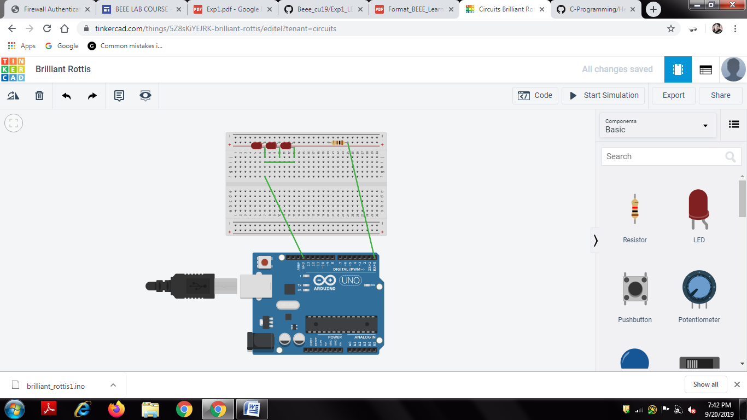

**CONCEPT USED :**

**LEARNING AND OBSERVATIONS:**

**PROBLEMS AND TROUBLESHOOTING:**

**PRECAUTIONS:**

**LEARNING OUTCOMES:**